STRATHFIELD GIRLS – YEAR 12 HALF YEARLY EXAM – 2008
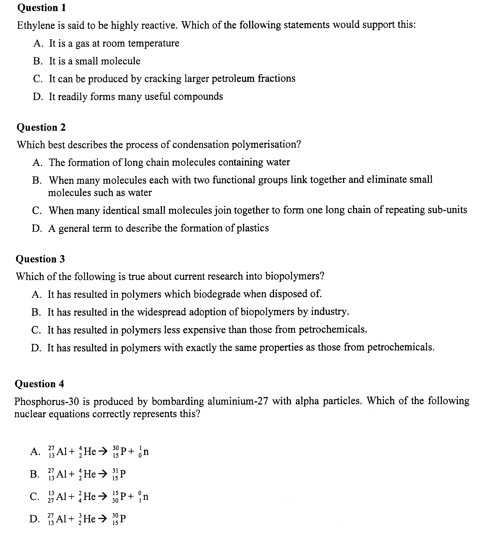

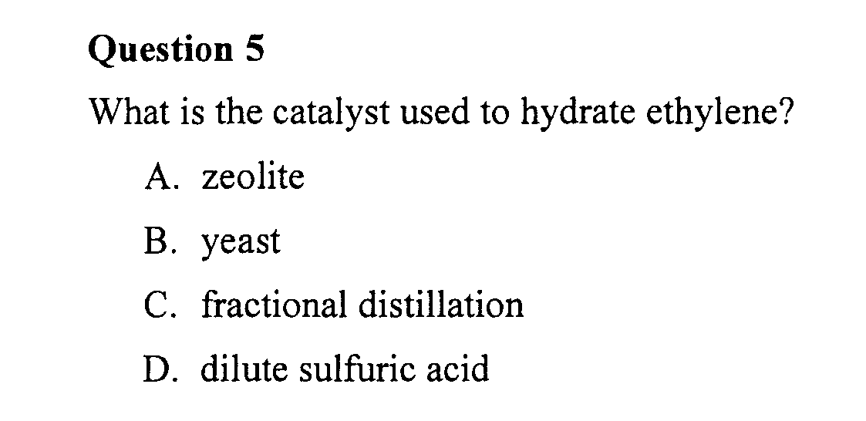

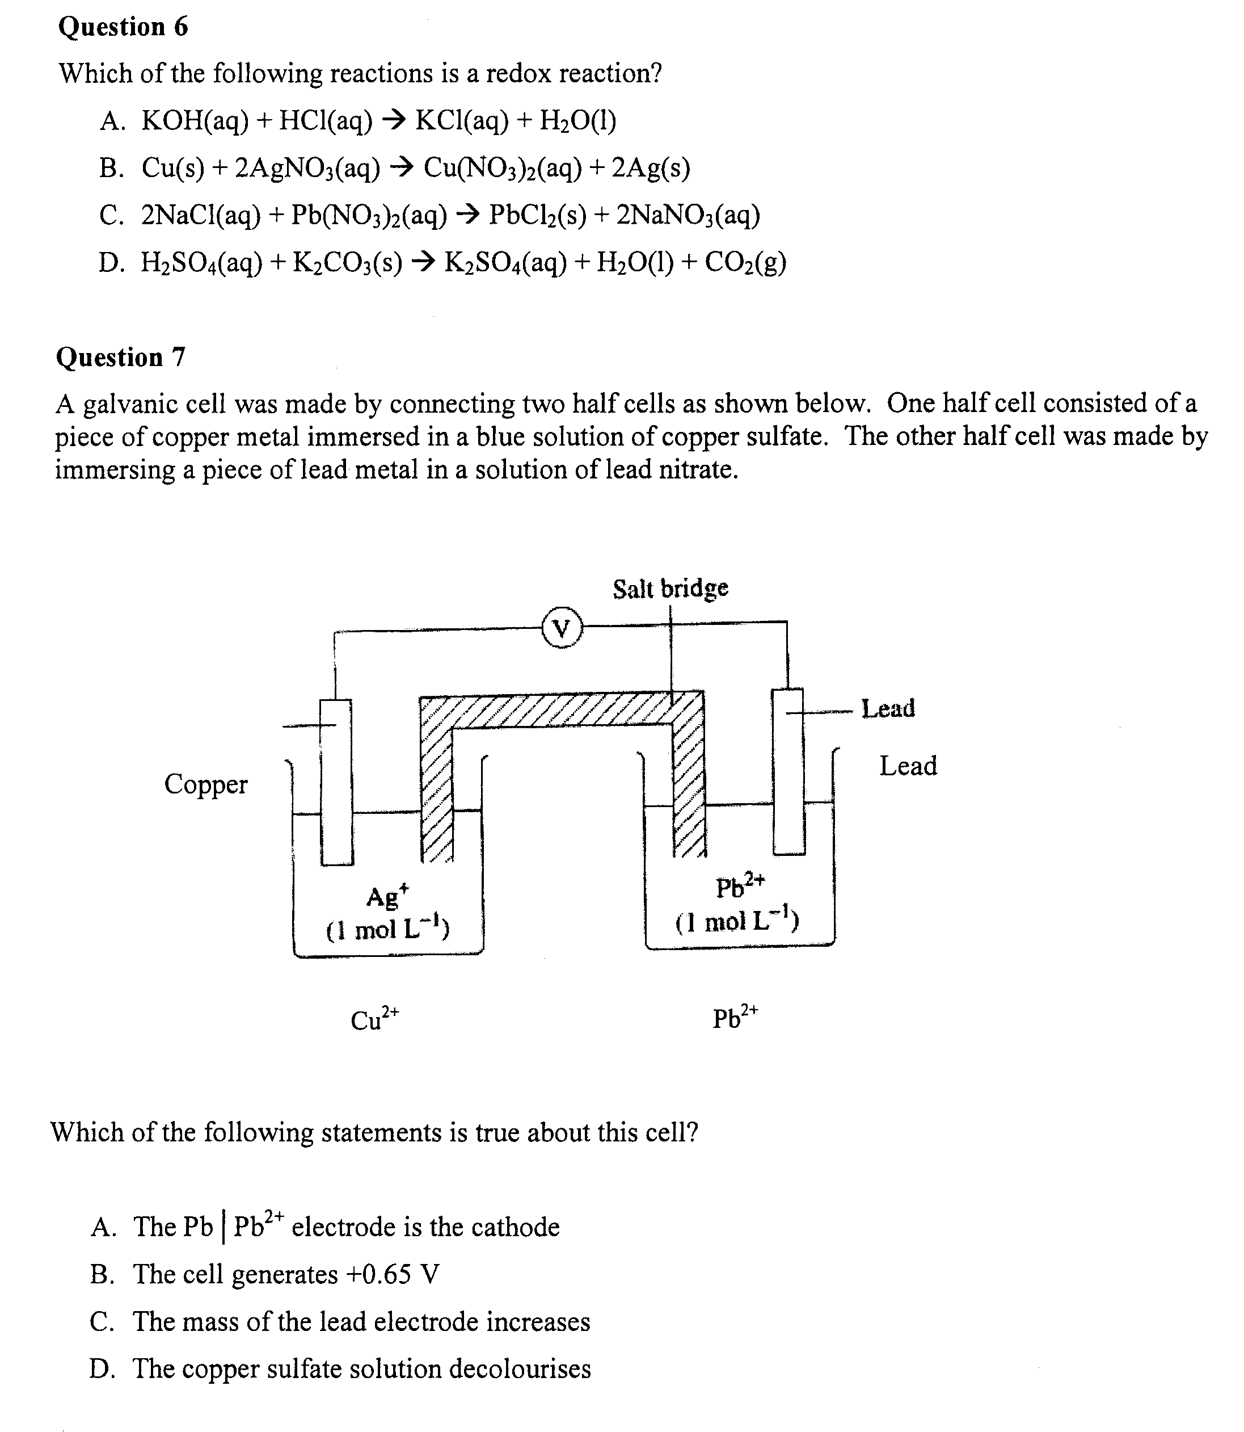

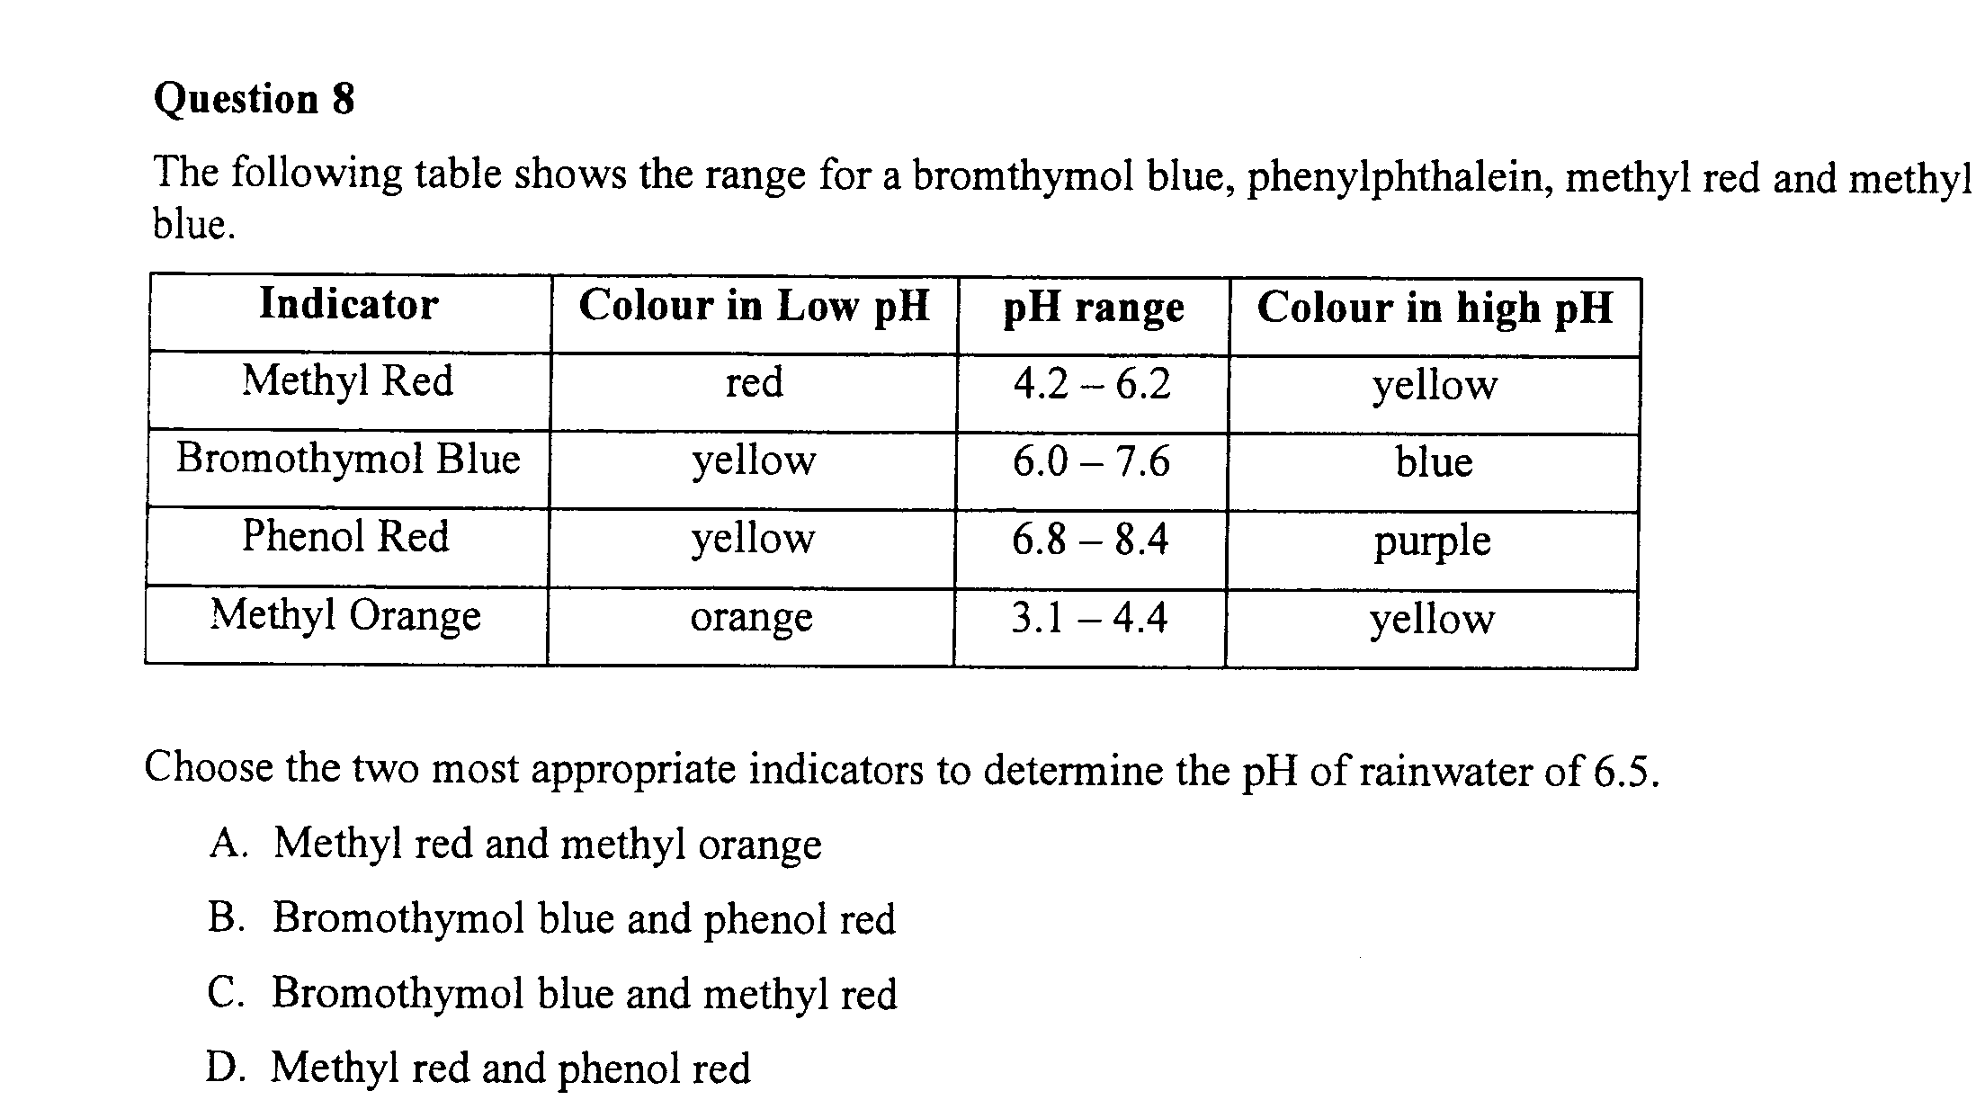

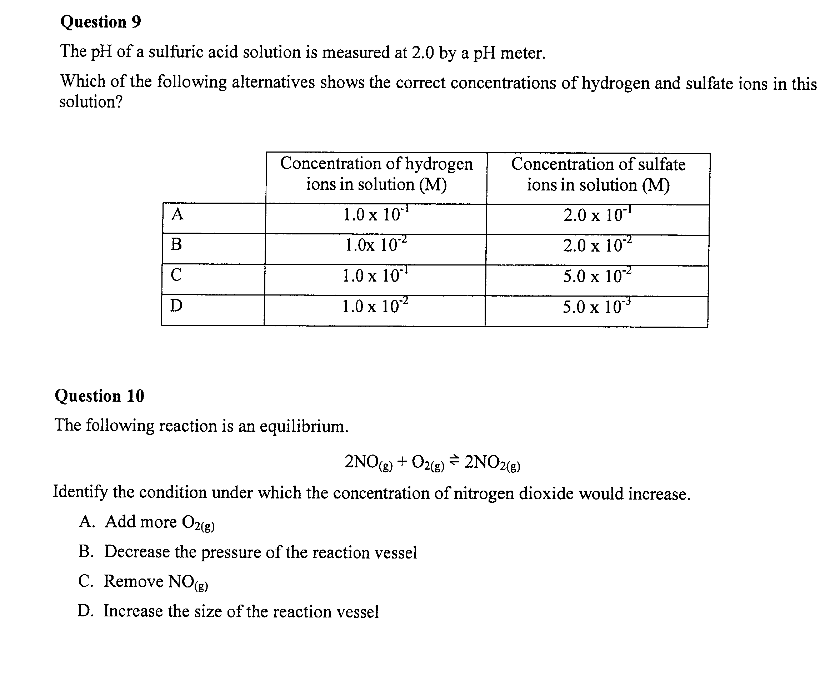

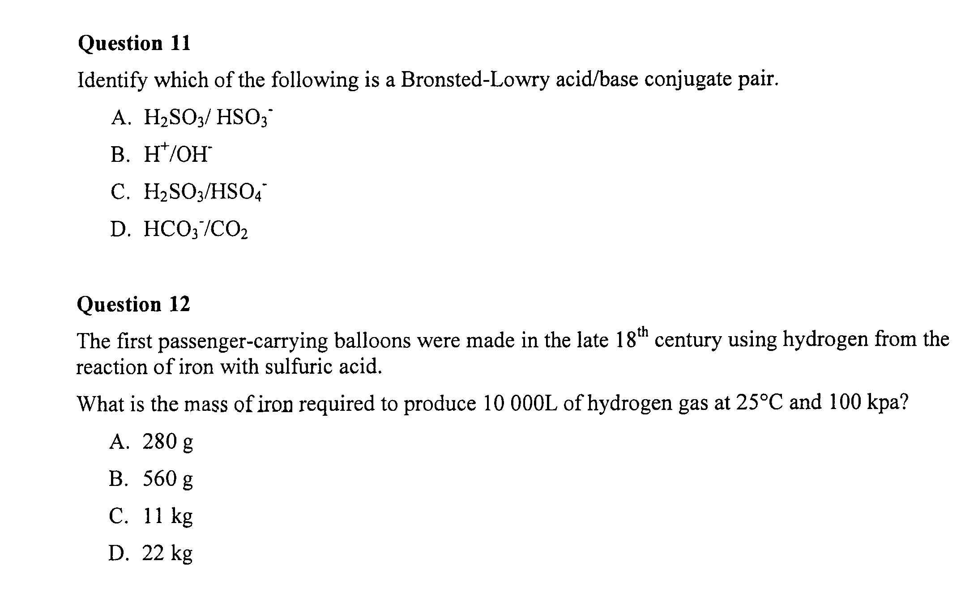

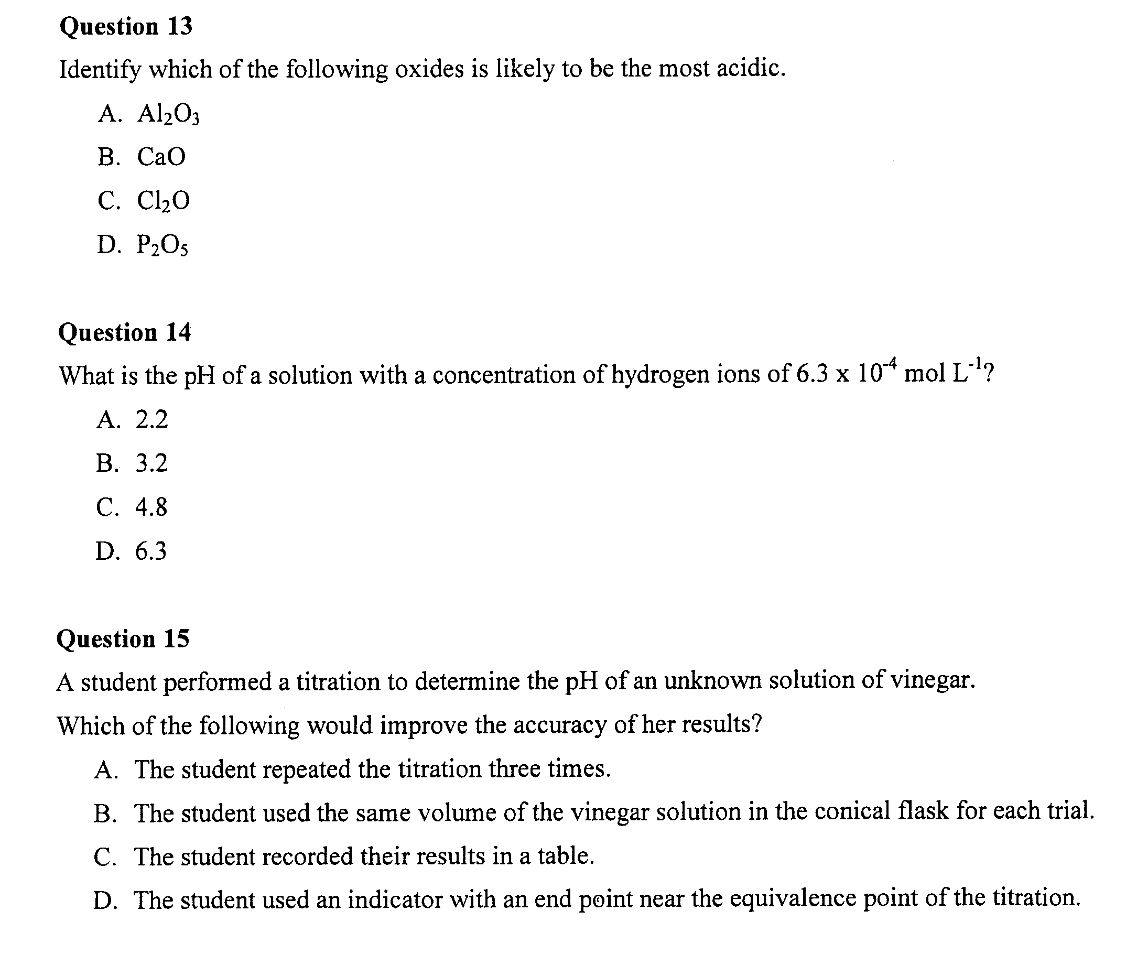

Question 16 (6 marks)

Polyvinyl chloride (PVC) is a polymer commonly used in water pipes, electrical conduit and containers for food and other organic materials.

a. Give the systematic name of the monomer used to produce polyvinyl chloride 1

…………………………………………………………………………………………………………..

b. Choose ONE of the above uses and identify properties of polyvinyl chloride that makes it 2
suitable for this use

…………………………………………………………………………………………………………..

…………………………………………………………………………………………………………..

…………………………………………………………………………………………………………..

c. The compounds used to produce polymers such as polyvinyl chloride are presently obtained from 3
the petrochemical industry. Discuss the need for alternative sources of these compounds and
identify one such source

…………………………………………………………………………………………………………..

…………………………………………………………………………………………………………..

…………………………………………………………………………………………………………..

…………………………………………………………………………………………………………..

…………………………………………………………………………………………………………..

…………………………………………………………………………………………………………..

…………………………………………………………………………………………………………..

…………………………………………………………………………………………………………..

…………………………………………………………………………………………………………..

Question 17 (2 marks)

Identify an instrument and outline the process used by this instrument to detect radiation 2

…………………………………………………………………………………………………………..

…………………………………………………………………………………………………………..

…………………………………………………………………………………………………………..

…………………………………………………………………………………………………………..

Question 18 (4 marks)

During your Chemistry course you performed a first-hand investigation to ferment glucose and 2
monitor mass changes

…………………………………………………………………………………………………………..

…………………………………………………………………………………………………………..

…………………………………………………………………………………………………………..

…………………………………………………………………………………………………………..

…………………………………………………………………………………………………………..

Question 19 (4 marks)

In your Chemistry course you have studied either the DRY CELL or LEAD-ACID CELL. Describe 4
the structure and chemistry for ONE of these cells and outline its impact on society

…………………………………………………………………………………………………………..

…………………………………………………………………………………………………………..

…………………………………………………………………………………………………………..

…………………………………………………………………………………………………………..

…………………………………………………………………………………………………………..

…………………………………………………………………………………………………………..

…………………………………………………………………………………………………………..

…………………………………………………………………………………………………………..

…………………………………………………………………………………………………………..

…………………………………………………………………………………………………………..

Question 20 (7 marks)

A student wanted to compare the heat of combustion of butan-1-ol with that of ethanol. To do this, they burned 1.55 g of butan-1-ol to heat 250.0 mL of water form 15.0ºC to 47.0ºC

- Draw the structural formula of butan-1-ol 1

- Using the student’s data, calculate the heat of combustion of butan-1-ol 3

…………………………………………………………………………………………………………..

…………………………………………………………………………………………………………..

…………………………………………………………………………………………………………..

…………………………………………………………………………………………………………..

c. Compare the student’s experimental value for butan-1-ol with the experimental value they 2
would obtain for ethanol. Explain your answer

…………………………………………………………………………………………………………..

…………………………………………………………………………………………………………..

…………………………………………………………………………………………………………..

…………………………………………………………………………………………………………..

d. State how the student’s experimental value would compare with the theoretical value (in the SI Data
Book) for butan-1-ol 1

…………………………………………………………………………………………………………..

Question 21 (4 marks)

a. Using any relevant equations, outline the formation of acid rain form industrial sources of 2
EITHER sulfur dioxide or nitrogen oxides

…………………………………………………………………………………………………………..

…………………………………………………………………………………………………………..

…………………………………………………………………………………………………………..

…………………………………………………………………………………………………………..

b. Describe TWO effects of acid rain 2

…………………………………………………………………………………………………………..

…………………………………………………………………………………………………………..

…………………………………………………………………………………………………………..

…………………………………………………………………………………………………………..

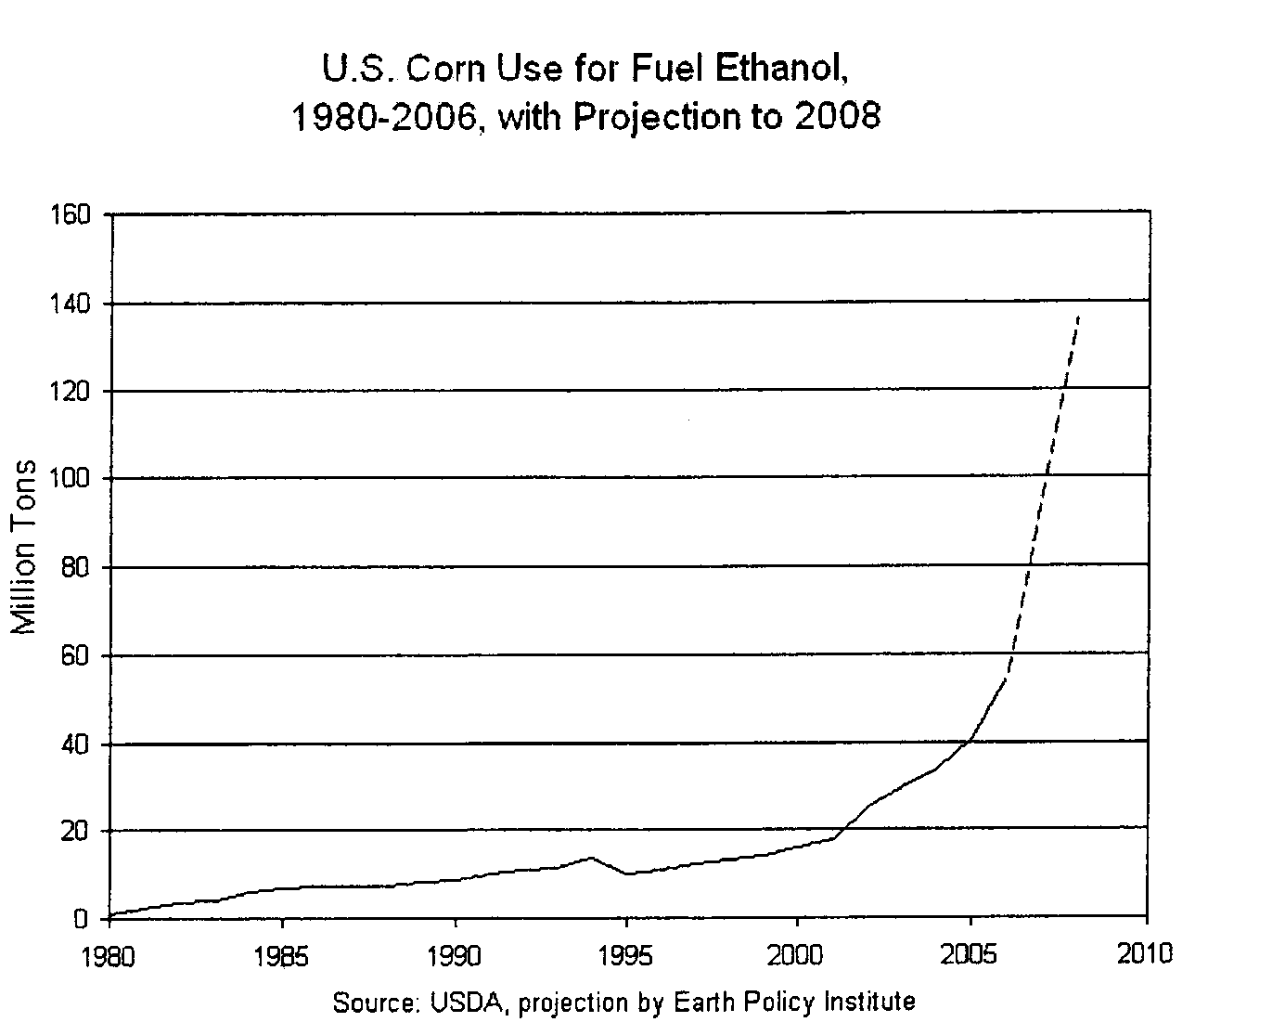
Question 22 (5 marks)

Evaluate the use of ethanol as an alternative fuel in terms of its impact upon society and the 5
environment using data in the graph

…………………………………………………………………………………………………………..

…………………………………………………………………………………………………………..

…………………………………………………………………………………………………………..

…………………………………………………………………………………………………………..

…………………………………………………………………………………………………………..

…………………………………………………………………………………………………………..

…………………………………………………………………………………………………………..

…………………………………………………………………………………………………………..

…………………………………………………………………………………………………………..

…………………………………………………………………………………………………………..

…………………………………………………………………………………………………………..

…………………………………………………………………………………………………………..

…………………………………………………………………………………………………………..

…………………………………………………………………………………………………………..

…………………………………………………………………………………………………………..

…………………………………………………………………………………………………………..

…………………………………………………………………………………………………………..

…………………………………………………………………………………………………………..

…………………………………………………………………………………………………………..

Question 23 (5 marks)

Analyse how an increased knowledge of the composition and properties of acids has led to 5
changes in the definition of acids

…………………………………………………………………………………………………………..

…………………………………………………………………………………………………………..

…………………………………………………………………………………………………………..

…………………………………………………………………………………………………………..

…………………………………………………………………………………………………………..

…………………………………………………………………………………………………………..

…………………………………………………………………………………………………………..

…………………………………………………………………………………………………………..

…………………………………………………………………………………………………………..

…………………………………………………………………………………………………………..

…………………………………………………………………………………………………………..

…………………………………………………………………………………………………………..

…………………………………………………………………………………………………………..

…………………………………………………………………………………………………………..

…………………………………………………………………………………………………………..

…………………………………………………………………………………………………………..

…………………………………………………………………………………………………………..

…………………………………………………………………………………………………………..

…………………………………………………………………………………………………………..

…………………………………………………………………………………………………………..

…………………………………………………………………………………………………………..

…………………………………………………………………………………………………………..

Question 24 (5 marks)

The following equation represents the solubility of carbon dioxide in water

CO_{2(g)} + H₂O_{(l)} ⬄ HCO₃⁻_{(aq)} + H⁺_{(aq)}

a. Hydrogen carbonate ion (HCO₃⁻) is an amphiprotic species. Define the term amphiprotic and write
TWO chemical equations to show that the hydrogen carbonate ion (HCO₃⁻) is amphiprotic 3

…………………………………………………………………………………………………………..

…………………………………………………………………………………………………………..

…………………………………………………………………………………………………………..

…………………………………………………………………………………………………………..

…………………………………………………………………………………………………………..

…………………………………………………………………………………………………………..

b. Explain the effect of the above equilibrium of increasing the temperature of the system 2

…………………………………………………………………………………………………………..

…………………………………………………………………………………………………………..

…………………………………………………………………………………………………………..

Question 25 (3 marks)

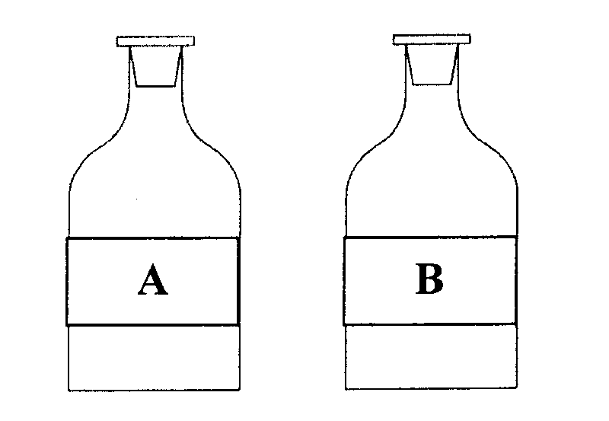
Two reagent bottles were filled with 0.1 mol/L solutions of hydrochloric acid and citric acid respectively. However, their labels were mixed up

Outline a test that could be performed to determine which bottle contains the hydrochloric acid and 3
explain why this test is appropriate

…………………………………………………………………………………………………………..

…………………………………………………………………………………………………………..

…………………………………………………………………………………………………………..

…………………………………………………………………………………………………………..

…………………………………………………………………………………………………………..

…………………………………………………………………………………………………………..
Question 26 (3 marks)

Ammonium nitrate is commonly used as an agricultural fertiliser. When it is washed into waterways 3
it is found to lower the pH

Explain this observation using appropriate equations to support your argument

…………………………………………………………………………………………………………..

…………………………………………………………………………………………………………..

…………………………………………………………………………………………………………..

…………………………………………………………………………………………………………..

…………………………………………………………………………………………………………..

…………………………………………………………………………………………………………..

Question 27 (2 marks)

Describe TWO uses of acid-base indicators 2

…………………………………………………………………………………………………………..

…………………………………………………………………………………………………………..

…………………………………………………………………………………………………………..

…………………………………………………………………………………………………………..

